Given the root of a binary tree, return the number of **uni-value** subtrees.

A **uni-value subtree** means all nodes of the subtree have the same value.

**Example 1:**

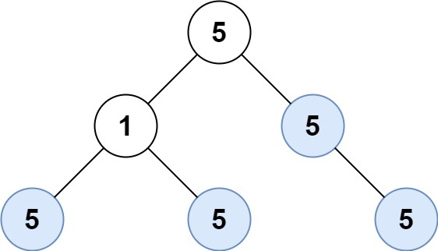

**Input:** root = [5,1,5,5,5,null,5]

**Output:** 4

**Example 2:**

**Input:** root = []

**Output:** 0

**Example 3:**

**Input:** root = [5,5,5,5,5,null,5]

**Output:** 6

**Constraints:**

* The numbrt of the node in the tree will be in the range [0, 1000].
* -1000 <= Node.val <= 1000